Center for Bio-Vibrational science
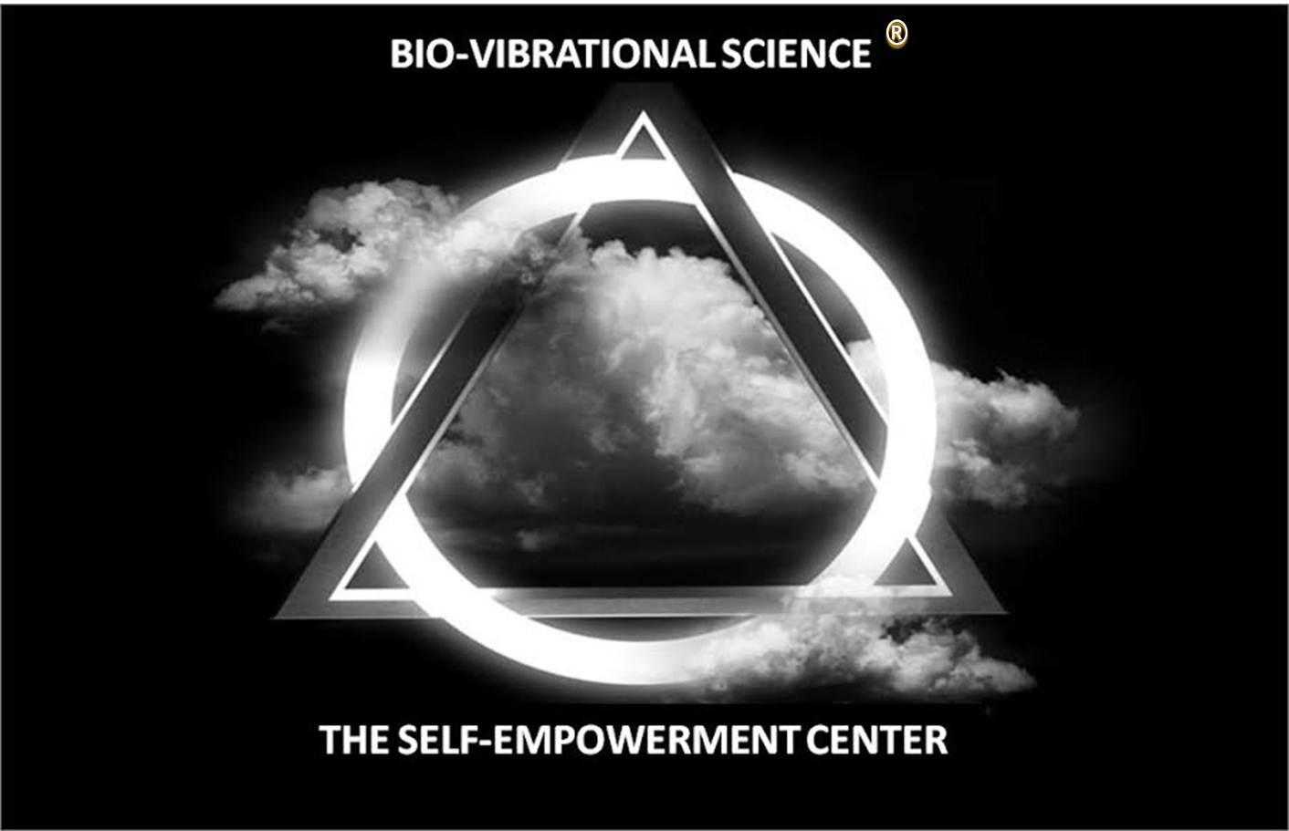

Student Application
Student Name: |  |  | Date:
Phone: |  |  | Birthday:
Email:

who invited you and/or how did you hear about the sec?
Name:
Relationship:

Invitation to become a student
- The SEC is the gathering place for Ascended Masters and the Beneficent Energy Beings who are guiding Humanity to Higher Consciousness
- These Ascended Masters and Beneficent Energy Beings are activating those of us who have accepted the five disciplines of Bio-Vibrational Science providing us with connection wealth (health) and access, peace, harmony and balance through Mind Science. The Ascended Masters and Beneficent Energy Beings protect us from attack and distractions through our faithful commitment to the Science as we seek to live according to our purpose.
- If it is your desire to be in this sacred circle of prosperity and protection we invite you to unite with us by becoming a student through recitation and honoring of the below statement:
On this day I commend I Am to a new way of life in me, I accept the presence of the Ascended Masters and Beneficent Energy Beings who seek to bring connection, wealth (health), access, peace, harmony, balance and protection into my life.
I release the negatives of the past
I espouse the now of my today and future
I commit my life to Bio-Vibrational Science and its disciplines and to spreading this Science to a critical mass of souls in universal order to bring about a positive change in Humanity
Ase'

What happens next
In a few days you will be contacted by a Bio-Vibrational Scientist who will invite you to participate in the new student ritual. In this ritual, new students wearing white will be asked to bring concealed statements on paper that reflect past struggles so that they might be cleansed from their mind. This action symbolizes the student leaving their past psychologies behind and joining our sacred circle. Secondly, Students will have their hands cleansed by the Acharya/Jaya in symbolism of their minds being immersed into Bio-Vibrational Science. Lastly the Acharya/ Jaya will anoint the students forehead with oil, opening the third eye of the student to the reality that they are the “I AM” Completion of this beautiful ritual and completion of our orientation classes will gain the student admission into the Mystery Temple of Bio-Vibrational Science. If you are in Houston you will need to deliver this application to the Center in person, online students may mail the application to info@biovibrationalscience.com
Student Signature |  |  | Date

